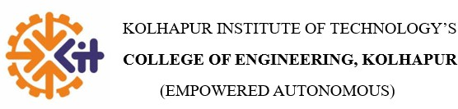

MINI PROJECT SYNOPSIS ON
“INNOVATIVE MENTOR CONNECT”

Submitted By

Name of Student | Roll No. | PRN Number
Nirjala Maruti Pujari | 02 | 2324000023
Maithili Mahesh Dhopate | 06 | 2324000116
Narayani Prithviraj Ghorpade | 18 | 2324000414

Under the guidance of
Mr. Uday Patil Sir



Project Title :
Innovative Mentor Connect

Introduction :
In educational institutions, students often require continuous academic guidance, proper mentoring, and easy access to learning resources. However, traditional mentoring and library systems operate independently and lack proper coordination. Manual mentor allocation, limited interaction between students and mentors, and inefficient library management affect students’ academic growth.
Innovative Mentor Connect is a web-based application designed to integrate student mentoring and library services into a single platform. The system focuses on improving student performance by providing structured mentor support and organized access to academic resources. It enables effective interaction between students, mentors, and the library system.
Students can register on the platform, upload academic details, and request mentor guidance. Based on predefined criteria, mentors are assigned to students to provide academic support through scheduled meetings and real-time communication. The system also includes a library module that allows students to search, view, and reserve academic resources digitally.
Mentors can monitor student progress, conduct meetings, and provide guidance, while the library module ensures efficient management of books and learning materials. The platform is developed using modern web technologies to ensure scalability, security, and ease of use.



Objective :
- To provide an integrated platform for student mentoring and library management.
- To improve student academic performance through structured mentor guidance.
- To enable efficient interaction between students and mentors.
- To allow students to access and reserve library resources digitally.
- To simplify mentor assignment and student monitoring.
- To reduce manual effort in mentoring and library operations.

Feasibility Study :
For the Innovative Mentor Connect system, the feasibility study confirms that the project can be successfully developed and implemented within the available resources, time, and technology.

Technical Feasibility
The project is technically feasible as it is developed using reliable and open- source technologies such as React, Node.js, Express.js, and PostgreSQL. Real- time communication is enabled using Socket.io, making student-mentor interaction efficient.

Operational Feasibility
The system is user-friendly and role-based, making it easy to operate for students, mentors, and library staff. Minimal training is required to use the platform effectively.

Economic Feasibility
The project is cost-effective as it uses open-source software and can be deployed on existing institutional infrastructure without additional hardware costs.

Need and Significance
The system fulfills the need for a unified mentoring and library platform that enhances academic support and resource accessibility for students.



Methodology and Technologies :
The proposed system, Innovative Mentor Connect, is designed to facilitate efficient interaction between students, mentors, and the library module through a structured web- based platform. The system manages student and mentor information, academic records, and resource access while ensuring proper role-based interaction among different users.
Student and mentor data are processed and organized using structured data handling techniques. Data preprocessing techniques are applied to manage missing values, clean datasets, and prepare structured information required for mentor assignment. Academic details such as skills, subjects, and CGPA are considered during the matching process.
To improve mentor–student assignment, semantic text representation techniques are used. Skill descriptions and interests of both mentors and students are converted into vector embeddings using the all-MiniLM-L6-v2 model available through Hugging Face. These embeddings capture the contextual meaning of the text rather than simple keyword matching. The similarity between student and mentor profiles is computed using cosine similarity, allowing the system to identify the most relevant mentor for each student.
The platform also supports grade card uploads for student verification. Uploaded documents are validated using PDF processing techniques to ensure that only valid academic documents are accepted. This ensures the reliability of academic information used within the system.
Overall, the methodology integrates data preprocessing, semantic similarity techniques, and role-based web architecture to create a scalable mentor–student interaction platform.



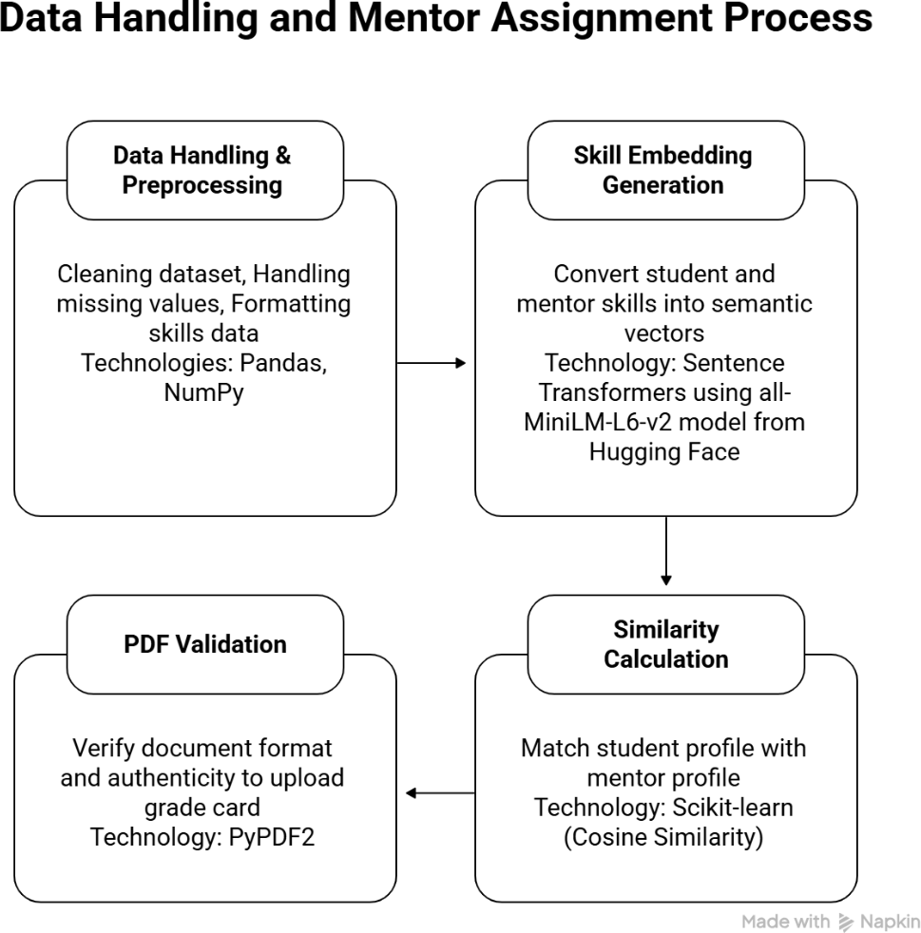

Project is an Application Based Project

Software / Hardware Requirements

Software Requirements :

  - Frontend: React (Vite), Tailwind CSS
  - Backend: Node.js, Express.js
  - Database: PostgreSQL
  - Authentication: Google OAuth
  - Realtime Communication: Socket.io
  - Email Service: Nodemailer
  - Operating System: Windows



Hardware Requirements :

  - RAM: Minimum 8 GB
  - Storage: 20 GB free disk space
  - Internet connection for OAuth and real-time feature

Benefits of the Project for the Society
  - Improves academic performance through personalized mentorship.
  - Reduces student dropouts by identifying weak learners early.
  - Enhances communication between students and mentors.
  - Promotes efficient utilization of library resources.
  - Provides career awareness and eligibility insights to students.
  - Supports digital transformation in educational institutions.

References :
- O. Ghorpade, O. Rane, and A. Singh, “Mentor Connect Platform,” MIT ADT University, Pune, India, 2024.

Bibliography :
  - React Official Documentation.
  - Node.js and Express.js Documentation.
  - PostgreSQL Documentation.
  - Google OAuth 2.0 Documentation.
  - Socket.io Official Documentation.

